**ERD Model PART 3**

Illustrate that you understand normalization and how to use it to reduce uncontrolled redundancy in your database design by creating two ERD diagrams:

**Answer:**

In this ERD reformation diagram we discover that redundancy from a connection or amassing of family members is confined via the direction of normalization. Insertion, deletion, and replacement abnormalities should end result from social overt repetitiveness. Redundancy in records set tables is removed or dwindled making use of normal structures.

By studying new records used in the desk, standardization assists with getting rid of intricacy and overt repetitiveness. The widespread records set desk may be separated into greater modest tables and related via connections. It holds a desk lower back from having replica records or rehashing gatherings.

**Create the first using UML and the Umlet free utility.**

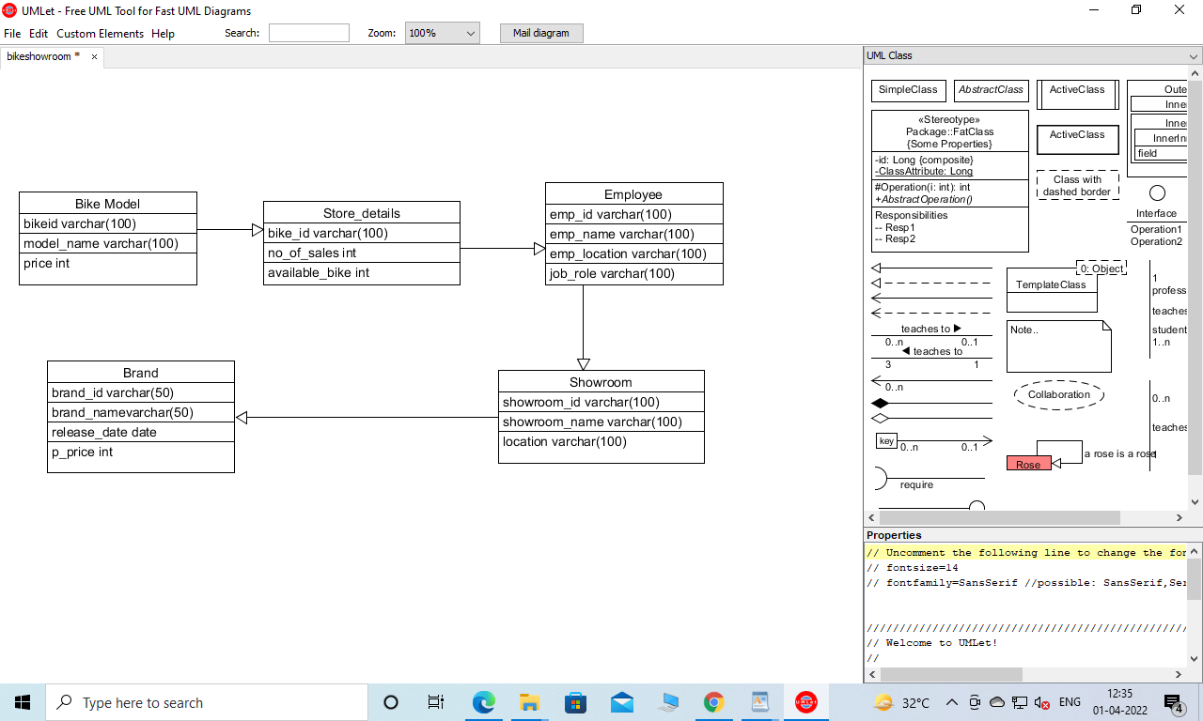

**Create the second using Crow’s Foot notation in Vertabelo.**

